OS Assignment-02

Jeetu Mehra
U24AI032

Question 1 : Write a Shell Script to find factorial of a number.
Code:
#!/bin/bas
echo "Enter a number:"
read n
fact=1
for (( i=1; i<=n; i++ ))
do
fact=$((fact * i))
done
echo "Factorial of $n is $fact"
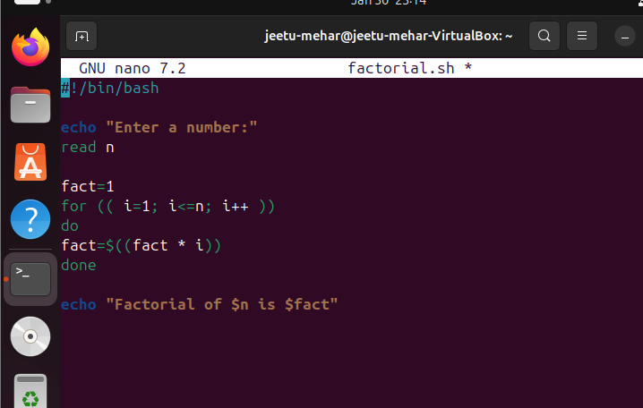
Output:
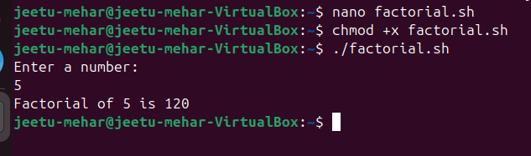

Question 2 : Write a shell script for a program to implement an address book with the options given below:
a) Create an address book.
b) View the address book.
c) Insert a record.
d) Delete a record.
e) Modify a record.
f) Exit.
Code:
#!/bin/bash

FILE="addressbook.txt"

while true
do
echo "------------------------"
echo " ADDRESS BOOK MENU"
echo "------------------------"
echo "1. Create Address Book"
echo "2. View Address Book"
echo "3. Insert Record"
echo "4. Delete Record"
echo "5. Modify Record"
echo "6. Exit"
echo "Enter your choice:"
read choice

case $choice in
1)
> $FILE
echo "Address book created."
;;
2)
if [ -s $FILE ]; then
cat $FILE
else
echo "Address book is empty."
fi
;;
3)
echo "Enter Name:"
read name
echo "Enter Phone:"
read phone
echo "Enter Email:"
read email
echo "$name | $phone | $email" >> $FILE
echo "Record inserted."
;;
4)
echo "Enter name to delete:"
read name
grep -v "^$name" $FILE > temp.txt
mv temp.txt $FILE
echo "Record deleted."
;;
5)
echo "Enter name to modify:"
read name
grep -v "^$name" $FILE > temp.txt
echo "Enter new Phone:"
read phone
echo "Enter new Email:"
read email
echo "$name | $phone | $email" >> temp.txt
mv temp.txt $FILE
echo "Record modified."
;;
6)
exit
;;
*)
echo "Invalid choice"
;;
esac
done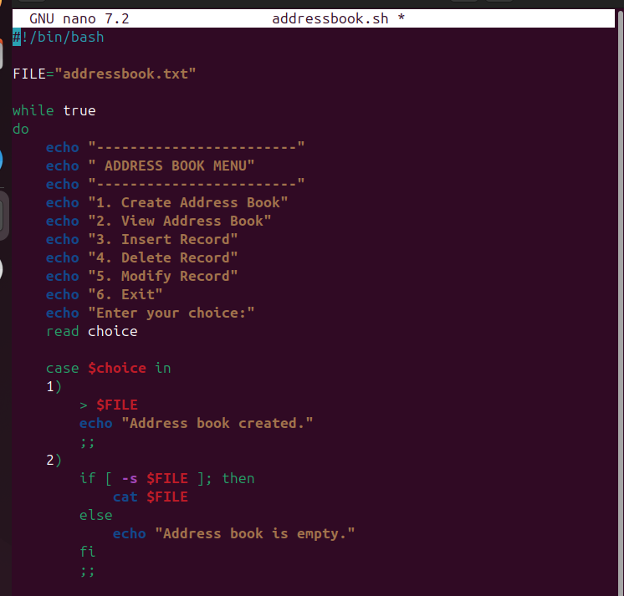
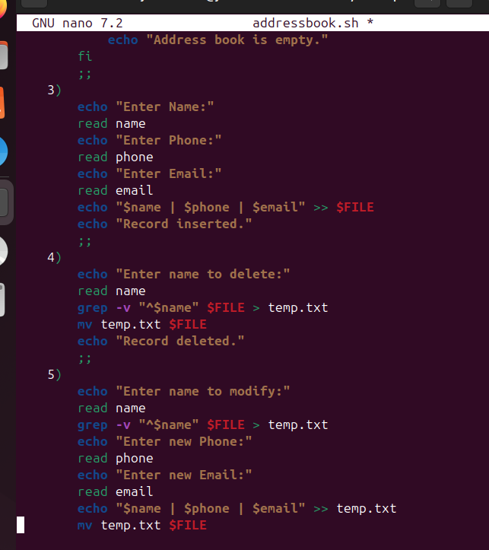
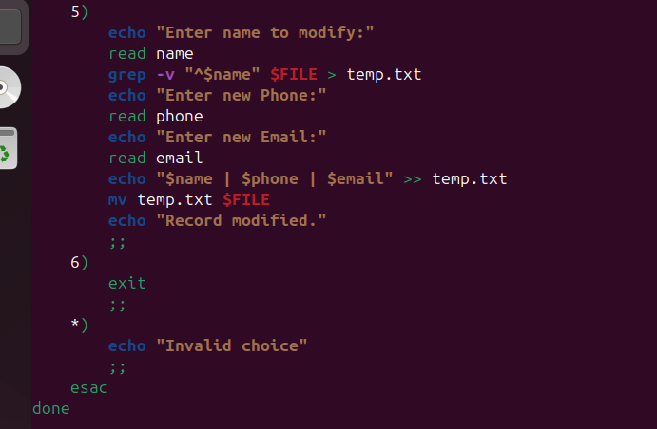
Output:
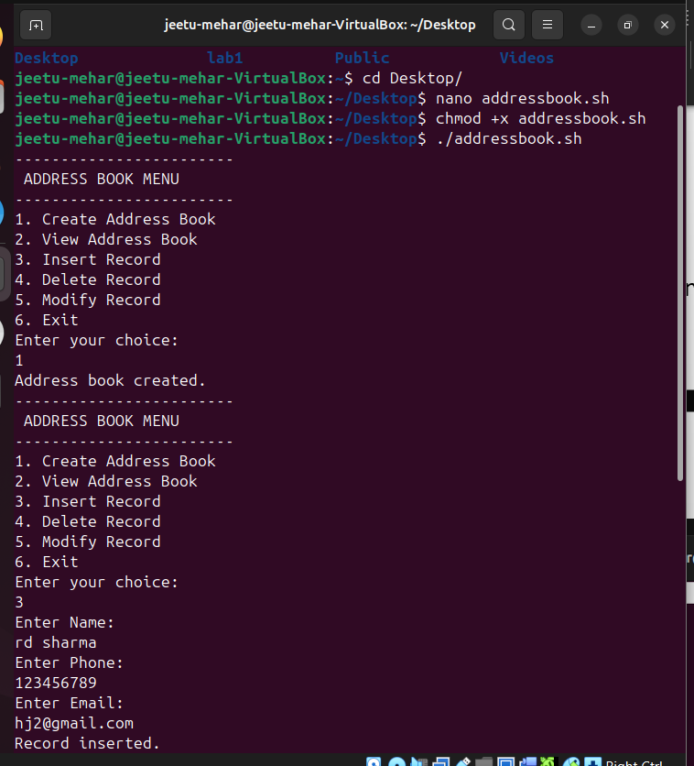

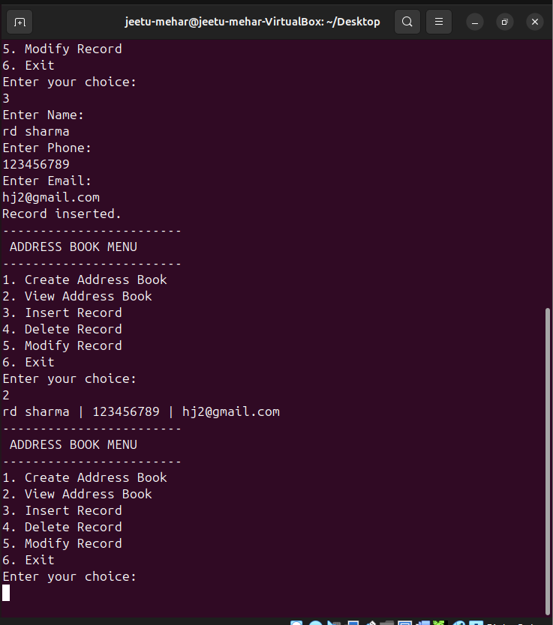

Question 3 : Write the shell script that renames all files in the current directory that end in “.jpg”
to begin with today’s date in the following format: YYYY-MM-DD.
For example, if a picture of cat was in the current directory and today was October
31,2016 it would change name from “mycat.jpg” to “2016–10–31-mycat.jpg”
Code:
#!/bin/bash
date=$(date +%Y-%m-%d)
for file in *.jpg
do
mv "$file" "$date-$file"
done
echo "Renaming completed"
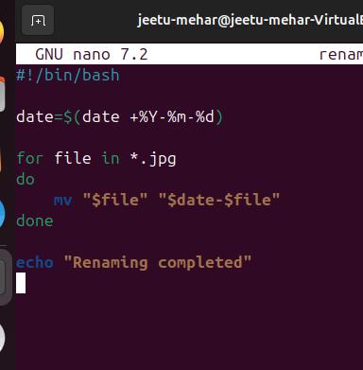
Output:
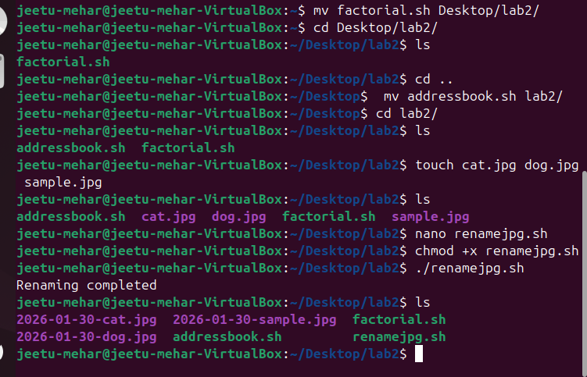

Question 4 : Write a shell script for a program with options to calculate the following:
a) Area of a circle
b) Circumference of a circle
c) Area of a rectangle
d) Area of a square
Code:
#!/bin/bash

echo "----------------------------"
echo " CALCULATION MENU"
echo "----------------------------"
echo "1. Area of Circle"
echo "2. Circumference of Circle"
echo "3. Area of Rectangle"
echo "4. Area of Square"
echo "Enter your choice:"
read ch

case $ch in
1)
echo "Enter radius:"
read r
area=$(echo "3.14 * $r * $r" | bc)
echo "Area of Circle = $area"
;;
2)
echo "Enter radius:"
read r
circum=$(echo "2 * 3.14 * $r" | bc)
echo "Circumference of Circle = $circum"
;;
3)
echo "Enter length:"
read l
echo "Enter breadth:"
read b
area=$((l * b))
echo "Area of Rectangle = $area"
;;
4)
echo "Enter side:"
read s
area=$((s * s))
echo "Area of Square = $area"
;;
*)
echo "Invalid choice"
;;
Esac
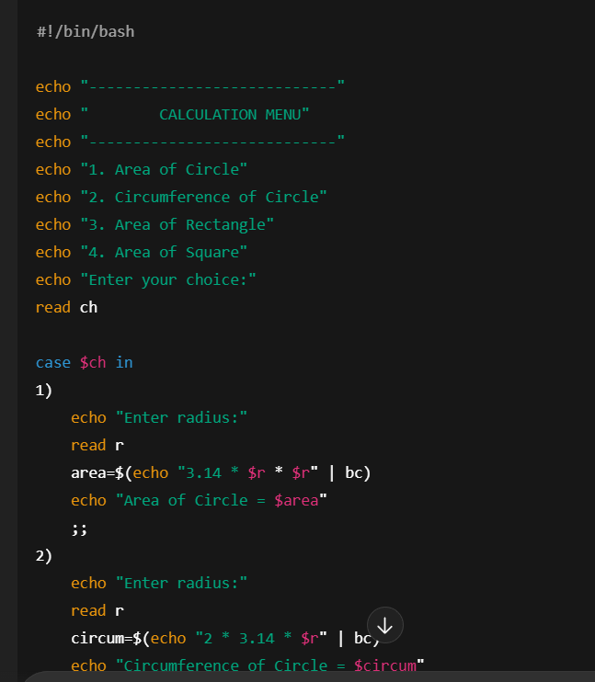
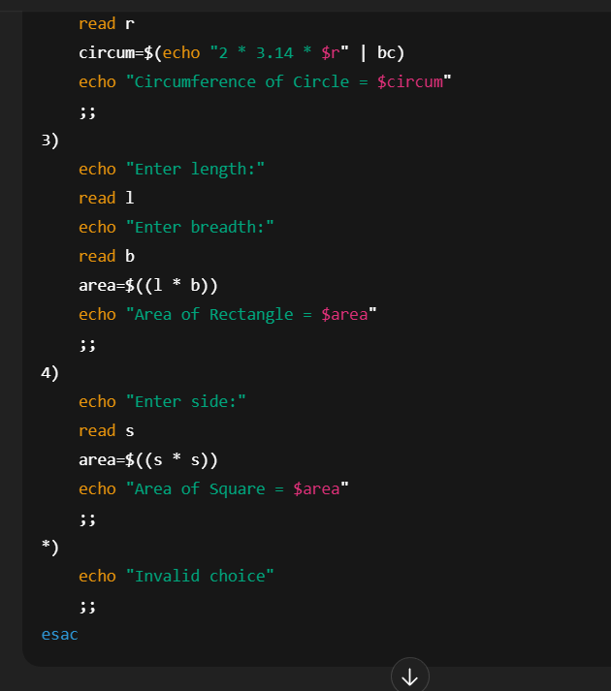
Output:
